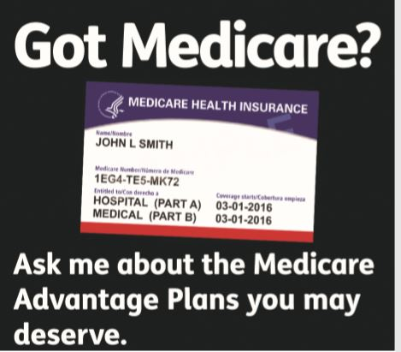

Licensed Sales Agent

DAMON GRIFFIN

832-494-5086 (TTY: 711)

Serving the Houston Metropolitan area

And The State Of Texas

**Have you…**

• Qualified for Medicaid?

•  Turned 65?

• Just moved?

• Become eligible for a Medicare Advantage and Prescription Drug Plan Special Enrollment Period for other reasons?

**Ask me about the Medicare Advantage Plans you may deserve.**